

**Department of**

**Computer Science and Engineering**

**Lab Report - 02**

Course No.              : CSE-308

Course Title             : System Analysis and Design Laboratory

Submitted By         :

  Name : 1 . Tasmim Sultana(129)

  2 . Fatama Jannat Tisha (131)

                                   3 .  Kamelia Zaman Moon (299)

                               4  .Umma Salma (302)

                                   5 . Sabrina Afrin Toma (304)

         Session        : 2017-18

         Semester     : 3rd year 1st Semester

Date            : 19-07-2020

Submitted To:

Md Musfique Anwar

         Associate Professor, Department of Computer Science and Engineering

         Dr. Md Humayun Kabir

Professor, Department of Computer Science and Engineering

Jahangirnagar University, Savar

**Experiment No.:** 02

**Title:** Activity 3.1 (Usage of GitHub)

**Objective:** To learn some of the basics for working with the Git version control system.

**Procedure:**

1. Logging in to GitHub website or creating an account.
2. Setting up Git and Mono to PC.
3. Setting up an account in Git command through terminal.
4. Getting a team of 3 people.
5. Assigning roles for each among Team Leader(TL), UI Coder(UC), Game Developer(GD).
6. TL:
   1. Forking a repository from the given link.
   2. Adding UI Coder, Game Developer as collaborators.
7. TL, UC, GD:
   1. Copying the project clone url from GitHub and pasting into a directory using terminal.
   2. Compiling & running the project.
8. UC:
   1. Adding a new font to the project resources.
   2. Modifying source code.
   3. Checking the change by compiling and running the program through the terminal.
   4. Committing and pushing the changes.
9. GD:
   1. Adding a game timer option to the Snap folder.
   2. Updating the game start and end procedure.
   3. Checking the change by compiling and running the program through the terminal.
   4. Committing and pushing the changes.
10. TL:
    1. Modifying the player hitting method.
    2. Checking the change by compiling and running the program through the terminal.
    3. Committing and pushing changes.
11. GD:
    1. Checking the master branch and pulling changes made by others.
    2. Merging and pushing the branches into master.
12. UC:
    1. Checking the master branch and pulling changes made by others.
    2. Merging the branches into master.
13. TL:
    1. Checking the master branch and pulling changes made by others.
    2. Merging the branches into master.

**Diagram:**

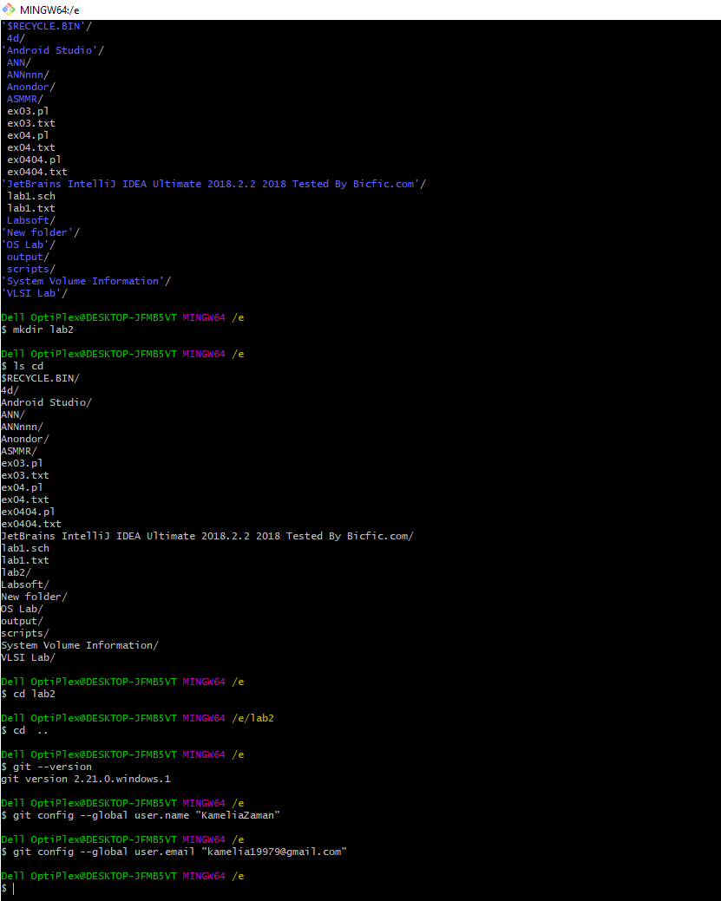

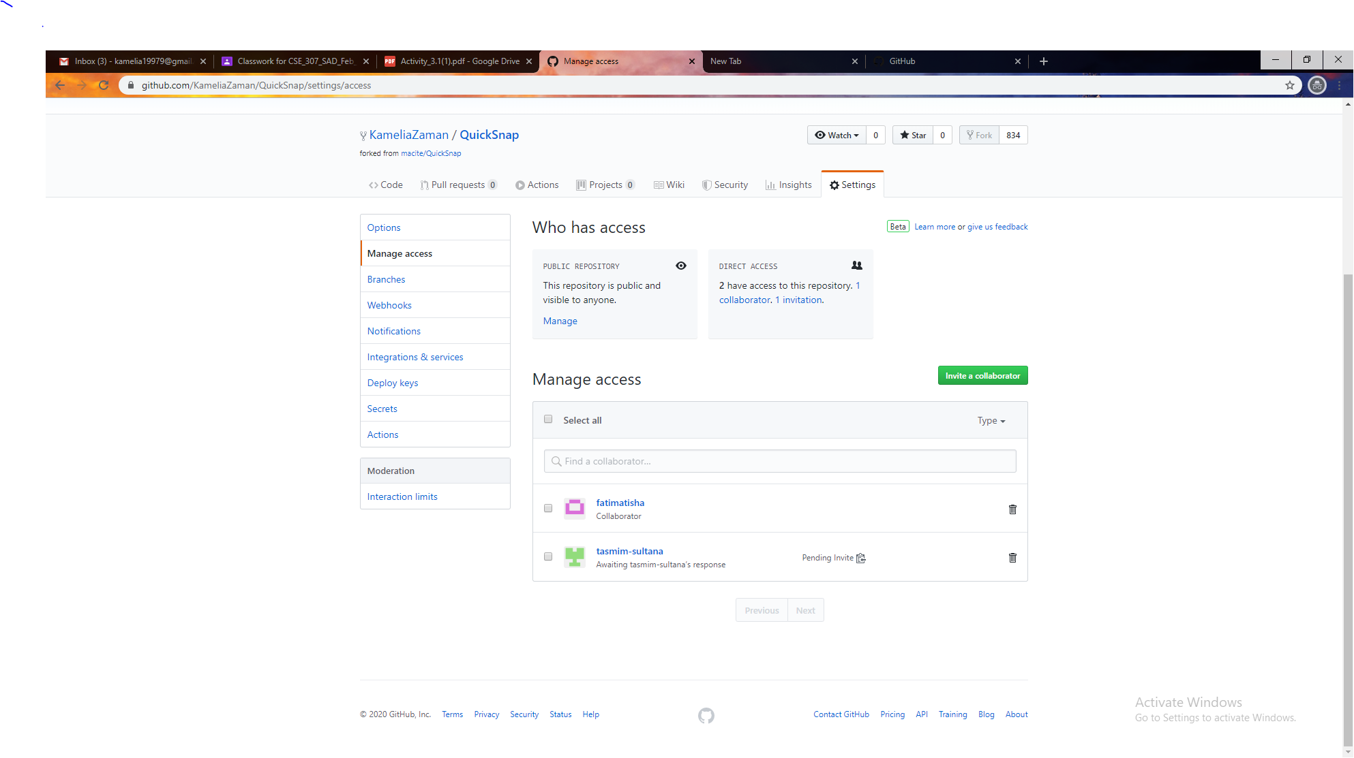

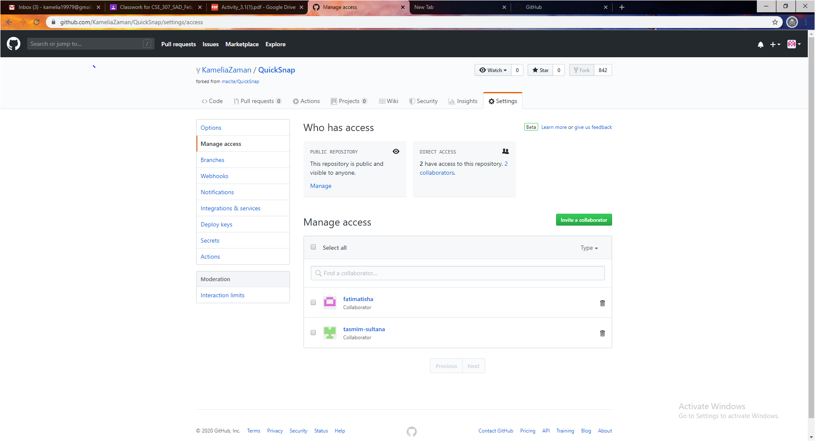

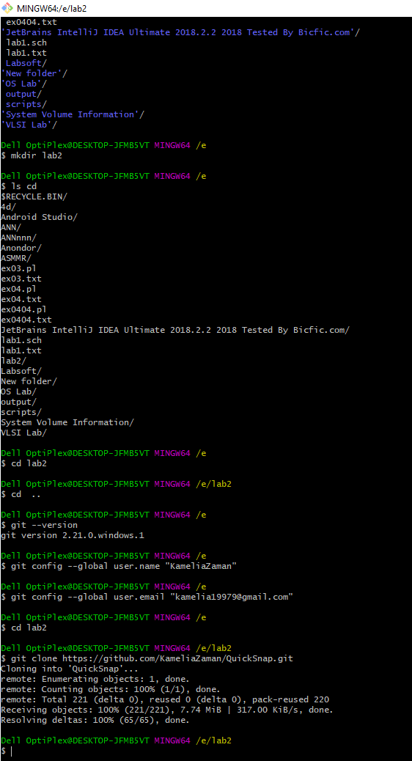

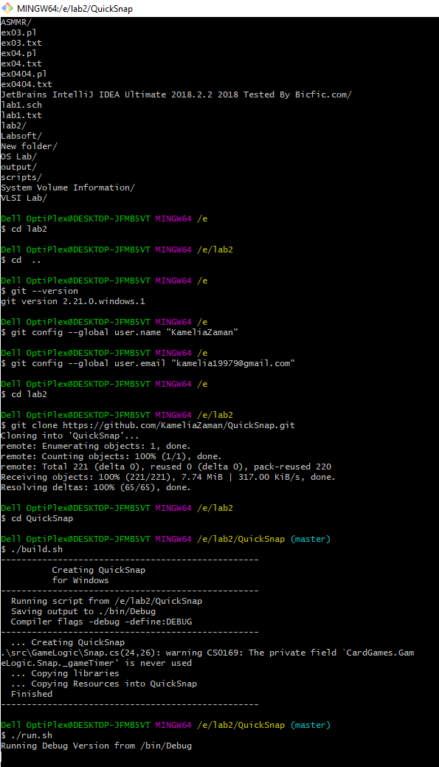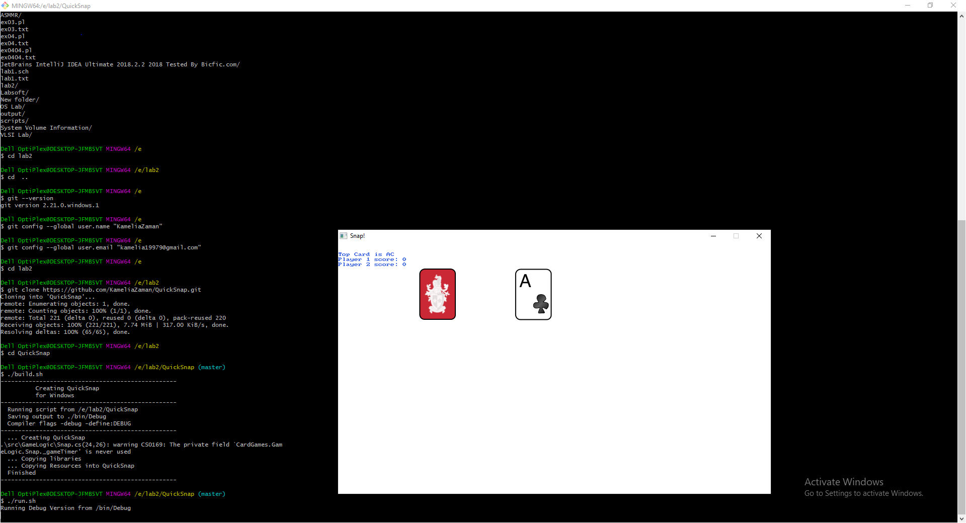

**Discussion:**

From this project, we can get an idea of how the GitHub and Git are used. We’ve got to know some of the functionalities like- forking & cloning a project, pushing and committing the changes for a project using Git command.